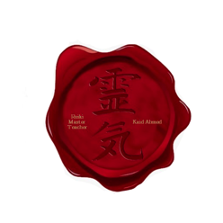
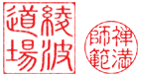
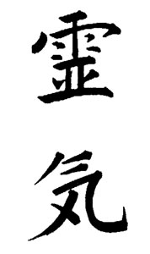

This CERTIFIES that

Your Name Here
Has successfully completed the required course of study in Usui Reiki Level 2
and is therefore awarded this Diploma and is Certified as an

Advanced Reiki practitioner
Awarded this _21st__ day of __February__, 2016__
Kaid Ahmed F.Inst.H.T., EFT-CC C.P.T.,C.Hyp

usui shiki ryoho
The International School Of Reiki | Reiki Master/Teachers

